

www.agilityio.com

ReactJS Practice Two

**17th Oct 2022**

# OVERVIEW

* This document provides information about ReactJS Practice Two. Build the list of items on the website.
* Design:

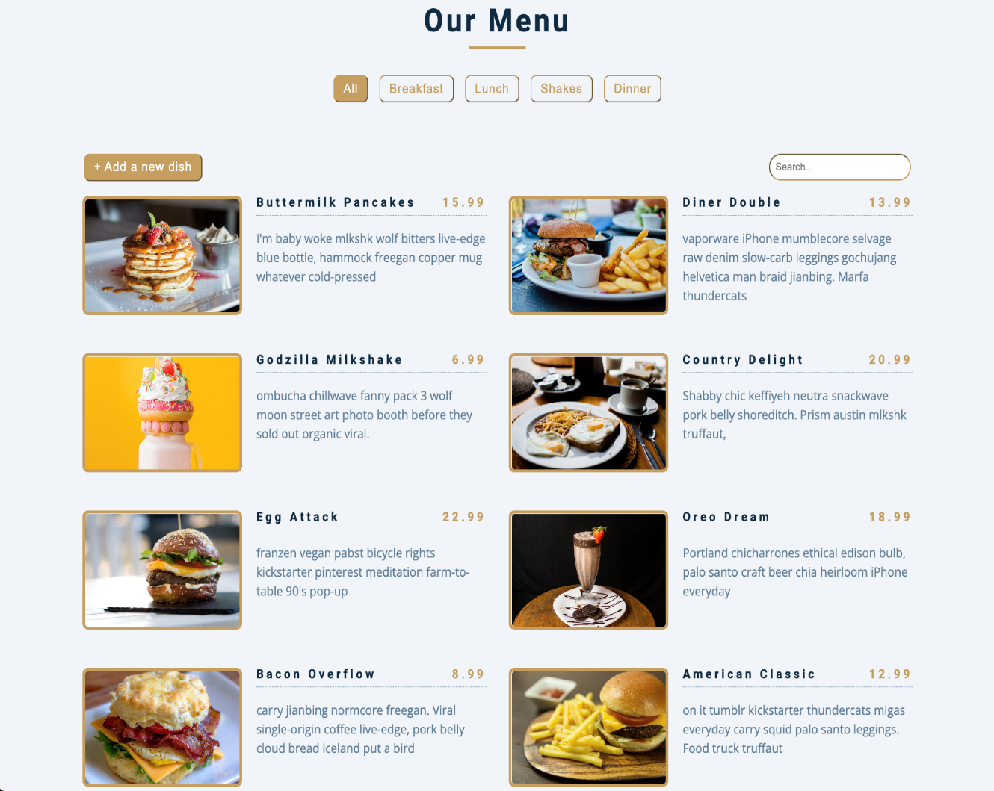

# TECHNICAL

* HTML5
* Module CSS
* ReactJS (Ver 18.2.0)
* React Router
* MockAPI
* Axios
* Storybook

**TIMELINE**

* 11 days (2022/10/17 – 2022/10/31)

**TEAM SIZE**

* 1 dev

**TARGETS**

* Build an application for managing items using React (Ver 18.2.0)
* Understand & apply knowledge of HTML5, Module CSS, Storybook, ReactJS
* Understanding & applying React Hooks, React Context, React Router
* Understand the importance of debug tools for front-end web developers (React DevTools, React perf.

**REQUIREMENTS**

* Build the application with the features below:
* Create mocking data:
* Render the list of the products.
* Add the product:
* The user can add a new product - Open the modal form to add a new one.
* Edit the product:
  + The user can edit the product when clicking the Edit button – Open the modal form to edit.
* Delete the product in the list:
* The user can delete the product when clicking the Delete button – Show the popup confirmation.
* Search the product by name:
* The user can search for the product by inputting the name of the product into the Searchbar.
* Sort the product:
* The user can sort products by category when clicking on the "Category" button.

**ANALYZING COMPONENTS**

|  |  |  |  |
| --- | --- | --- | --- |
| **#No** | **Component** | **Props** | **Events** |
| **1** | Button | label, classname, click, textColor, buttonColor | **onClick** |
| **2** | Modal | children | **onOpen, onClose** |
| **3** | Input | label, textField |  |
| **4** | Search bar | children | **onSearch** |
| **5** | Product List | showModal |  |
| **6** | Card Product | image, title, price, description |  |
| **7** | Image | urlImage, altImage, widthImage, heightImage |  |
| **8** | Select | label, option | **onSelect** |
| **9** | Form | title, price, description | **onOpen, onSubmit, onClose** |

**ESTIMATION DETAILS**

|  |  |  |  |  |
| --- | --- | --- | --- | --- |
| **#No** | **Date** | **Tasks** | **Estimate (h)** | **Status** |
| **1** | 2022/10/17 | * Analyzing requirements | **3** |  |
| * Create an Estimation file | **2** |  |
| * Create all tasks in GitLab Issues. | **2** |  |
| **2** | 2022/10/18 | * Init Project * Setup folder structure * Init package Vite, Pre-commit Hook – Prettier * Config the Storybook, | **2** |  |
| * Create the README.md file | **1** |  |
| * Analyze Design | **2** |  |
| * Break The UI Into a Component Hierarchy | **3** |  |
| **3** | 2022/10/19 | * Implement UI (Home) * Create component Navigation * Create component Button * Create component Input * Create component SearchBar * Create component Select | **4** |  |
| * Implement UI (Product Detail) * Create component Product List * Create component Card Product * Create component Image | **4** |  |
| **4** | 2022/10/20 | * Implement UI (Modal) * Create component Modal * Create component Form | **4** |  |
| * Implement the feature renders the list of product | **3** |  |
| **5** | 2022/10/21 | **Implement the feature add the product** | | |
| * Show the add modal | **2** |  |
| * Get the value from modal | **3** |  |
| * Validate date entered in form | **3** |  |
| **6** | 2022/10/24 | * Save data into the database | **2** |  |
| * Get data from database | **3** |  |
| * Render the list of the product after adding | **3** |  |
| **7** | 2022/10/25 | **Implement the feature to edit the product** | | |
| * Show the edit modal | **3** |  |
| * Get the data of the chosen product | **3** |  |
| * Validate data entered in form | **3** |  |
| **8** | 2022/10/26 | * Save the change data into the database | **4** |  |
| * Render the list of the product after edited | **4** |  |
| **9** | 2022/10/27 | **Implement the feature to delete the product** | | |
| * Show the delete popup confirm | **3** |  |
| * Delete data in database | **2** |  |
| * Render the list of the product after deleted | **3** |  |
| **10** | 2022/10/28 | **Implement the feature to search the product by name** | | |
| * Get the name of the product from input search | **4** |  |
| * Render the list of the product after searched | **4** |  |
| **11** | 2022/10/31 | **Implement the feature to sort the product by category when clicking on Sort button** | | |
| * Sort the product by category | **3** |  |
| * Render the list of the product after sorted | **2** |  |
|  |  | * Implement the Storybook into the project. | **3** |  |